Web: www.fabianeducation.com
Twitter: @EduFabians

🎄Fabian Education Policy Group Newsletter🎄

Edition 2

Winter 2022-3

In this newsletter:
1. Autumn Term 2022 round-up
2. 2023 dates for your diary
3. 'A Better Education?’
4. Further opportunities to write for us and share your ideas
5. IMPORTANT! Last call for submissions: "Labour's First Day" document
6.What's new on our blog, at the website, and on our social media pages.

WELCOME…

…colleagues old and new to this Winter 2022-3 Fabian Education Policy Group newsletter. Edition 2 gathers together news and notices that you may find useful.

As well as our round up of recent activities, the 'dates for your diary' section gives a flavour of what’s coming up in 2023.

This newsletter also contains our regular reminders about how you can share your ideas- whether it's writing a short essay or a blog piece, or producing something longer, we want to hear from you and can provide a platform for your work. In addition, our new publications project- “A Better Education?”- launches in the new year. See below for details.

With best wishes for the season and thanks for your continued interest, support and participation,

The FEPG organising committee.

1. Autumn Term 2022 round up

We held Zoom meetings in September, October and November.

The September and November meetings featured guest speakers. In September, Ellie Costello of Square Peg joined us, to talk about issues relating to barriers around school attendance. In November, Jack Worth of the NFER joined us to talk about recruitment and retention issues in the teaching profession.

You can access the minutes of these and other meetings at any time, by signing up and logging in to the members' section of our website, www.fabianeducation.com.

We also held a public meeting at the House of Commons in early November. The theme was "Early Years- A Fresh Start? Issues and Solutions". The full report can be read here:

https://fabians4education.edublogs.org/2022/11/11/report-early-years-a-fresh-start-issues-and-solutions-mark-williams/

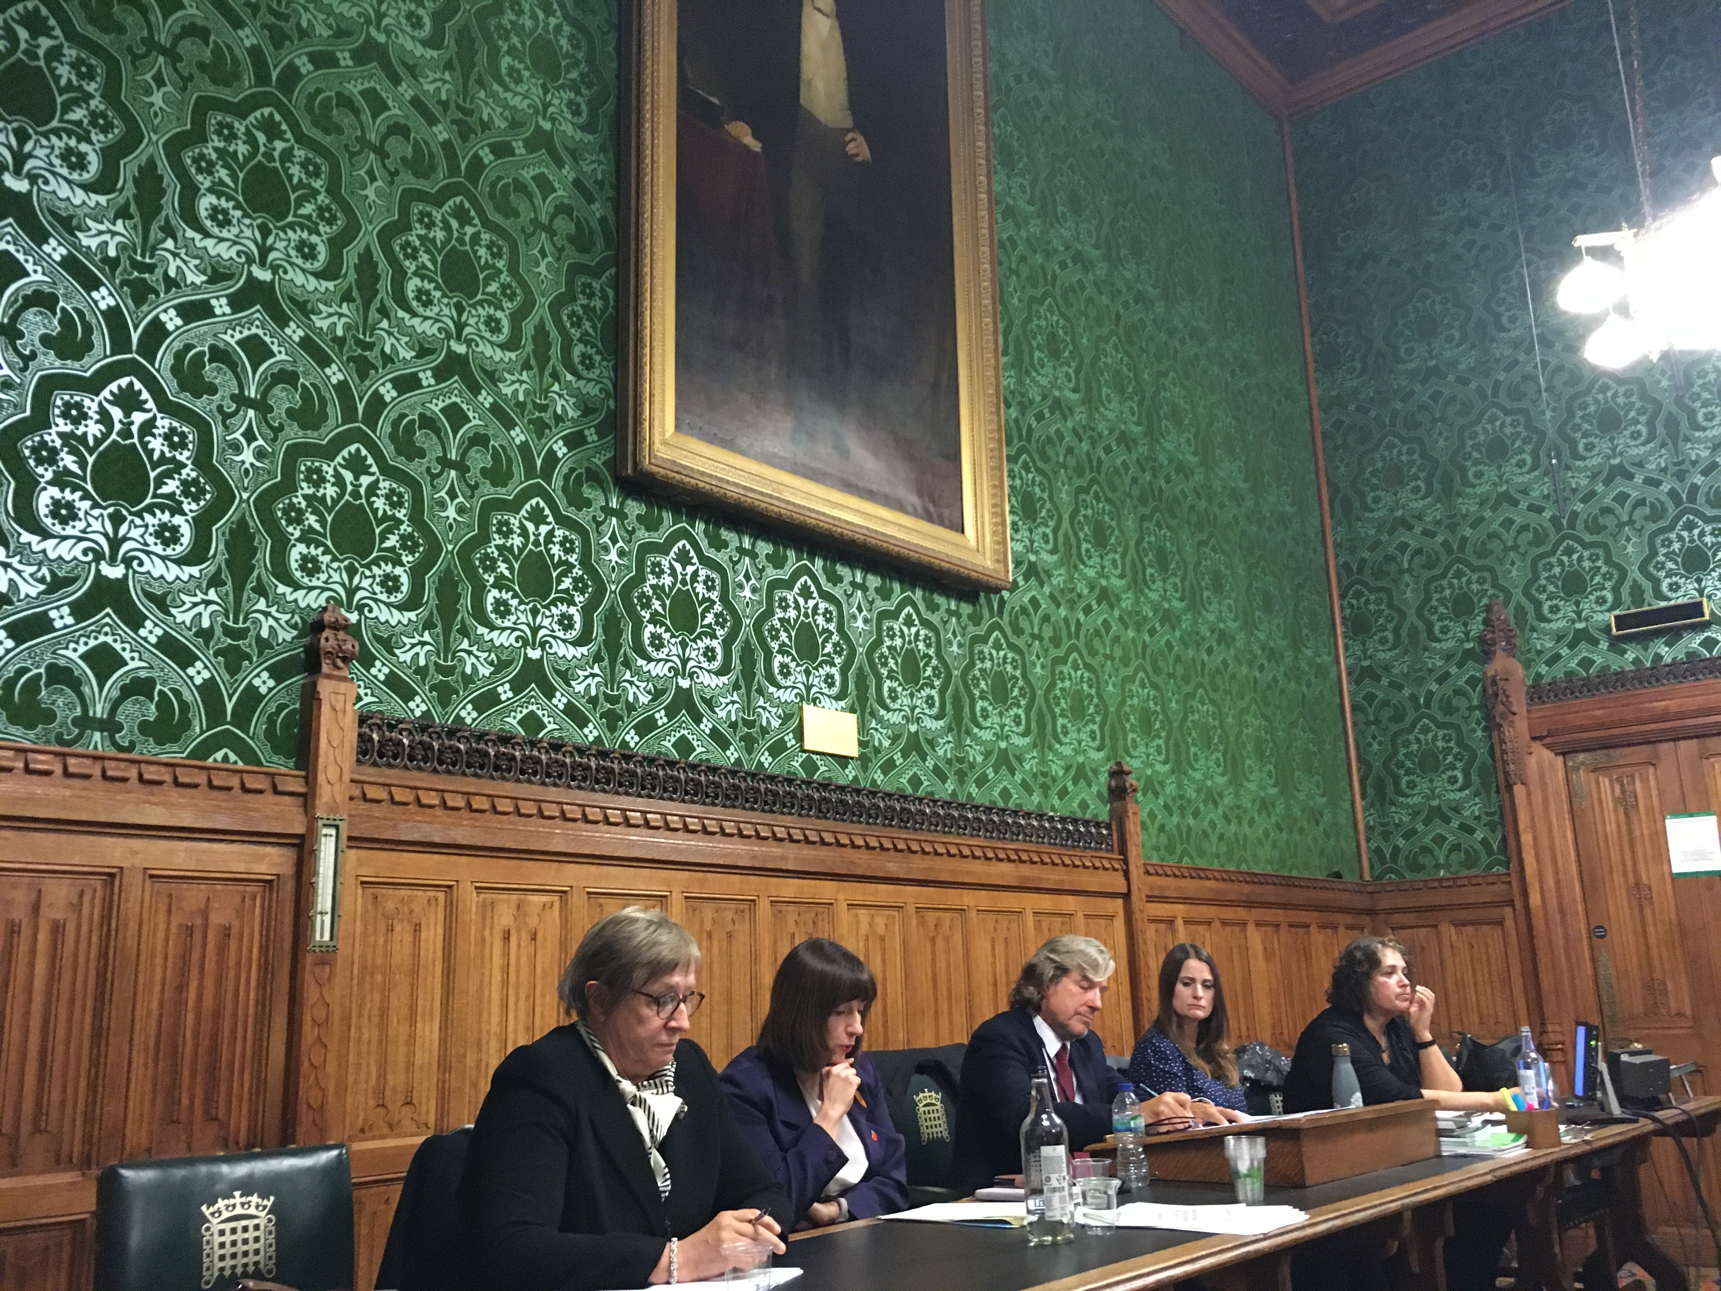
Above: The panel for the Early Years event (L-R- Eli Sunby, Bridget Philipson MP, FEPG Vice-Chair Chair Harris [who also chaired the event], Kate Hoskins and Siraj Iram).

2. Dates for your diary

Monday 19th December- FEPG online quiz and social evening at 7pm./

Join the meeting by using this link:

Join our Cloud HD Video Meeting

Join our Cloud HD Video Meeting
Zoom is the leader in modern enterprise video communications, with an easy, reliable cloud platform for video an...

Meeting ID: 822 1269 3261
Passcode: 906917

Saturday, 21st January 2023: Fabian Society New Year Conference (more details here: https://fabians.org.uk/event/feps-fabian-new-year-conference-2023/).
Some of us will be in attendance on the day to promote the FEPG. Come and say hello if you’re going! If you know other Fabian Society members who aren’t signed up to the FEPG, why not suggest they pop along on the day to find out more about us?

Monday, 30th January 2023, 7pm: Nick Thomas-Symonds MP. THIS IS A BIGGIE SO SAVE THE DATE. This is our monthly Zoom meeting, at which are really fortunate to be joined by Nick Thomas-Symonds MP.

Nick will be attending in his capacity as a historian and an author, and will be talking about his new book about Harold Wilson, The Winner.
For more information about the book, see the link here: https://www.weidenfeldandnicolson.co.uk/titles/nick-thomas-symonds/harold-wilson/9781474611954/

It promises to be a fascinating evening. Whether you lived through some or all of the Wilson years, or only know of the former Prime Minister as a historical figure, this is a chance to learn a lot more about this pivotal politician, and (from an education and broader social perspective) his role in shaping some of the landmark reforms of the post-war period.

IMPORTANT: Please note that Nick will NOT be attending in his capacity as an MP or to talk about current Labour Party policy, and he will not be fielding questions about these or related matters.

Monthly Zoom meetings- these will continue in 2023, usually on the last Monday of the month. The current dates for 2023 are as follows:
Jan 30th, Feb 27th, March 27th, April 24th, May 22nd, June 26th, July 17th (possibly to include a Summer social), September 25th, October 30th, November 27th, December 18th (Christmas social).

House of Commons public meetings- also slated for the Spring term (theme: OFSTED) and the Summer term (theme: educational technology). More details to follow as plans are finalised.

Also, please see the following from our colleagues at the Fabian Law and Constitutional Policy Group:

The next meeting of the Fabian Law and Constitutional Policy Group will be on 12 January at 7pm.

Frances Crook OBE, the co-convenor of the Commission on Political Power will be joining us to present the work of the Commission and to take questions from Members.
The Commission on Political Power’s purpose is to review where power is within government and how to make it work better. Frances will discuss the Commission’s findings so far and take questions on the health of British democracy.
Frances is a former Chief Executive of the Howard League for Penal Reform (until 2021). She has been an elected Councillor, a non-executive NHS director and university governor.

Members with any questions can contact the Group Chair (hannah.mchugh@outlook.com) and are invited to join via Zoom at the following link for this exciting discussion:

https://ucl.zoom.us/j/94750242287

3. “A Better Education?”

Plans for a Fabian Education Policy Group publication (see last newsletter and minutes of previous meetings) are going ahead. Now with a working title of A Better Education?, this is intended to be a collection of essays that we will publish initially at the blog.
More information will be to follow in January, but to whet your appetite here's an overview of what we have in mind.

Format: to be published initially on the FEPG blog site, under the series title "A Better Education?" Essays will be 2,500 max. We are working on a template for submissions so we all follow a common format. Full editorial support will be provided, and where possible we will facilitate co-writing with other members of the FEPG network.
Purpose: To inform the audience about the educational topic under discussion, and to persuade them that an alternative course of action is desirable.
Audience: WIDE- Key stakeholders- not just policy makers/ politicians, but crucially practitioners (and others directly involved in education) and parents/ guardians.
Tone/ style/ language: accessible and “pracademic”, i.e. it should be intellectually sound and underscored by evidence (like an academic text would be), and it should have a practical focus. In other words, try to present ideas that could be put into action and that also speak convincingly to non-practitioner stakeholders (like parents).

The three areas we're going to focus on for the first batch of essays are as follows: 1. SEND/ Inclusion; 2. Teacher education, including recruitment and retainment; and 3). Curriculum and assessment.

A number of people have already written blog pieces for the FEPG that we think could be expanded and republished under the "Better Education?" tag. If you are one of these contributors, look out for an e-mail in early 2023 asking if you'd like to build on your ideas and contribute to "A Better Education?".

4. Further opportunities to write for us and share your ideas

Blogs. We are always on the look out for new blogs from members. If there is an issue you would like to write about then please get in touch. Our blog pieces are usually under 1000 words. For inspiration take a look at our blog site here:
https://fabians4education.edublogs.org

Longer essays (aka the 'Journal'). If you would prefer to stretch out a little, we publish longer pieces (more than 1000 words) under the 'Journal' tab at our website. Take a look here: https://www.fabianeducation.com/journal
We haven't had any journal submissions for a while, so if you have some spare time over the Christmas and new year period and would like to get some ideas down, now is the time...

Six Searching Questions. If you have never written for us before, and would like to get started, we have a feature at our blog site called 'Six Searching Questions.' This is a short-form Q+A style blog, and it would be great to get lots of members contributing to this. Take a look here, and if you fancy tackling the questions get in touch.
We're not looking for lengthy essays or journals here- just short and concise answers to the questions, the kind of thing you can complete in ten or fifteen minutes:
https://fabians4education.edublogs.org/2022/01/23/a-new-series-of-posts-six-searching-questions-answered-by-professor-marilyn-leask/

5. Last Call for submissions: "Labour's First Day" document

Following the meeting in June 2022, between the Bridget Philipson (Shadow Secretary of State for Education) and members of the FEPG committee, we have a document that we would like all members to help us prepare.

It's called 'Labour's First Day and First White Paper' and it can be accessed here:

https://docs.google.com/document/d/102JJx5UTkkU6iL_VZBi5Lw0vx-E_kNcLF01mJ35gAgA/edit

What do you think a Labour government should do when it is in power? The idea is to populate this document with ideas which can be fed through to Bridget and her team, in the hope that as many of them as possible being out into action.

Take a look at the document, and if you feel inspired make a suggestion.
This document contains links to other FEPG documents which contain a wealth of ideas. Please take a look at these and use them for inspiration.

The Editorial group will work on this document on January 9th, so please ensure you have made your comments before this date. Once again, the document can be found here:

FEPG ideas: Labour’s first day and first White Paper

6. What's new on our blog, social media pages and at the website

Blog: There’ve been some new pieces published at the blog since our last newsletter, the most recent being a piece on curriculum reform by our FEPG Curriculum Working Group. Take a look here: https://fabians4education.edublogs.org

Twitter: Follow us @EduFabians. We're adding new followers all the time. Don't forget to retweet our posts to spread the word about us.

Our website www.fabianeducation.com remains the go-to source of information for all things relating to the FEPG. If you haven't already done so, please sign up for the 'Members' Area' of the site, where you will find documents like minutes of previous meetings.

