Web: www.fabianeducation.com
Twitter: @EduFabians

Fabian Education Policy Group Newsletter

Edition 3

Summer 2023

In this newsletter:
1. Spring/Summer 2023 round-up
2. The rest of 2023 dates for your diary and key speakers at our Monday meetings.
3. The Technology/AI House Of Commons event in November
4. The Online ‘Open School’ Event in early 2024.
5. The FEPG Submissions to the Labour party policy forum.
6.What's new on our blog, at the website, and on our social media pages.

WELCOME…

…Colleagues old and new to this Summer 2023 Fabian Education Policy Group newsletter. Edition 3 gathers together news and notices that you may find useful.

As well as our round up of recent activities, the 'dates for your diary' section gives a flavour of what’s coming up in the rest of 2023 and early 2024.

This newsletter also contains our regular reminders about how you can share your ideas- whether it's writing a short essay or a blog piece, or producing something longer, we want to hear from you and can provide a platform for your work.

Here’s hoping you are having a good summer and finding the best weather!

The FEPG organising committee.

1. Spring and Summer 2023 round up

We held Zoom meetings in January, February, March, April and June.

All meetings featured guest speakers. In January, colleagues Brian Lighthill and Deborah Outhwaite talked about their recent visit to the progressive XP School in Doncaster.

In February, Stephen Morgan, Shadow Minister of State for Education, joined us, to talk about Labour’s plans and potential offer at the next election.

In March, James Mannion, of Rethinking Education presented a series of ideas regarding improving education at a system level, and helping schools get even better at what they do.

In April, Chris Bagley discussed his ‘States of Mind research’ and the ‘Breaking the Silence’ Project where students created data sets regarding the impact of current Ofsted Inspections and possible new accountability models.

In May, Dr Tony Breslin discussed his recent research and books into the impact of the pandemic on schools, children and young people and school staff.

In June, Nick Thomas- Symonds MP gave a talk about his recent book ‘The Winner’ on the legacy of Harold Wilson.

You can access the minutes of these and other meetings at any time, by signing up and logging in to the members' section of our website, www.fabianeducation.com.

We also held a very successful public meeting at the House of Commons in March. The theme was Ofsted- A fresh Start: Issues and Solutions. The full report can be read here:
Events | Fabian Education Pol

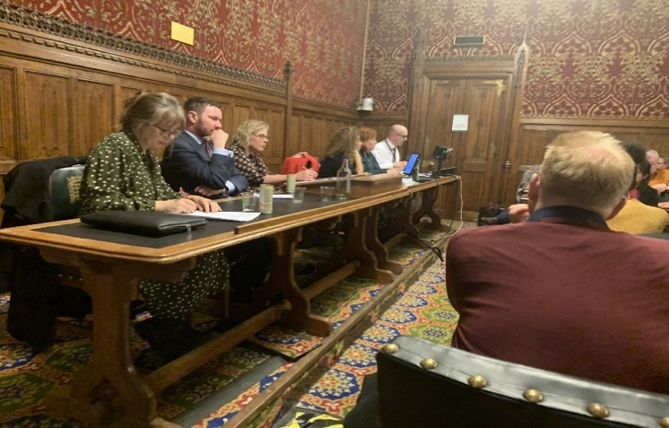

Above: The panel for the Ofsted event (L-R) Professor Sarah Younie, Tom Middlehurst ASCL, Dr Deborah Outhwaite (Chair for FEPG), Alison Kriel Former Trust CEO, Ros McMullen, Former Trust CEO Headrest and Heads’ Round table, Steve Rollett, Confederation of Schools Trust.

2. Dates for your diary

Monday 25th September 7.00pm-9.00pm: FEPG online meeting with a full agenda and guest speaker and leader of Islington Council, Kaya Comer Schwartz who will be talking about Free School Meals policy and its impact.

Monday 30th October 7.00pm-9.00pm: FEPG online meeting with a full agenda and guest speaker Ian Widdows University of Sheffield PHD researcher on Accountability Measures in Secondary schools.

Tuesday 7th November 7.00pm-9.00pm: House of Commons Seminar - Educational Technology and AI: Challenges, opportunities and targets.

Monday 27th November: FEPG online meeting with full agenda and guest speaker Professor Mel Ainscow who will be talking about ‘ How to make trust-led systems work’ through new forms of local coordination.

Zoom links and more details will be sent out about all this meetings/events in due course.

An event to look forward to early in 2024:

Following on from our House of Commons face to face meeting on Tuesday 7th November,an online event about the concept of ‘The Open School’. The Open School concept is partly about tech-based innovation, but equally about equity and access - especially for guaranteeing better access for Children and Young People who face barriers to attendance in legacy settings (i.e. buildings; silent classrooms etc).
FEPG aims to co-produce a Zoom meeting with other stakeholders and groups that share these interests and concerns.

3. Technology/AI event in November at the House of Commons

If you are interested in being involved or speaking at this event, please email us by September 21st when we have our planning meeting.

4. Further opportunities to write for us and share your ideas

Blogs. We are always on the look out for new blogs from members. If there is an issue you would like to write about then please get in touch. Our blog pieces are usually under 1000 words. For inspiration take a look at our blog site here:
https://fabians4education.edublogs.org

Longer essays (aka the 'Journal'). If you would prefer to stretch out a little, we publish longer pieces (more than 1000 words) under the 'Journal' tab at our website. Take a look here: https://www.fabianeducation.com/journal
We haven't had any journal submissions for a while, so if you have some spare time over the Christmas and new year period and would like to get some ideas down, now is the time...

Six Searching Questions. If you have never written for us before, and would like to get started, we have a feature at our blog site called 'Six Searching Questions.' This is a short-form Q+A style blog, and it would be great to get lots of members contributing to this. Take a look here, and if you fancy tackling the questions get in touch.
We're not looking for lengthy essays or journals here- just short and concise answers to the questions, the kind of thing you can complete in ten or fifteen minutes:
https://fabians4education.edublogs.org/2022/01/23/a-new-series-of-posts-six-searching-questions-answered-by-professor-marilyn-leask/

5. FEPG Submissions to the Labour Party Policy Forum and Shadow Team

Following meetings in June 2022, with Bridget Philipson (Shadow Secretary of State for Education) and in February 2023 with Stephen Morgan ( Shadow Minister for Education), members of the FEPG committee completed documents that members helped us to prepare. Many Thanks for this,

The Full Report is called:
‘Labour’s Preparation for Government
- Establishing Commissions, maximising impact during the First Hundred Days and beyond.
There is an introduction and compression document too and they can be accessed here:

Labour briefing papers '23 | Fabian Education Pol

6. What's new on our blog, social media pages and at the website

Blog: There’ve been some new pieces published at the blog since our last newsletter, the most recent being a piece on ‘Managing the educational market place’ Collaboration, conscience and context by Mel Ainscow and Paul Armstrong.
Twitter: Follow us @EduFabians. We're adding new followers all the time. Don't forget to retweet our posts to spread the word about us.

Our website www.fabianeducation.com remains the go-to source of information for all things relating to the FEPG. If you haven't already done so, please sign up for the 'Members' Area' of the site, where you will find documents like minutes of previous meetings.

Have a wonderful end of Summer and see you in the Autumn!

