Web: www.fabianeducation.com
Twitter: @EduFabians

Fabian Education Policy Group Newsletter

Edition 4

New Year 2024

In this newsletter:
1. Autumn 2023 round-up
2. The 2024 dates for your diary
3. Details of the proposed webinars and House of Commons event for 2024
4.Our new Cartoon series
5. Opportunities to write for us
6.What's new on our blog, at the website, and on our social media pages.

WELCOME…

…colleagues old and new to this New Year, 2024 Fabian Education Policy Group newsletter. Edition 4 gathers together news and notices that we are sure you will find interesting and useful..

As well as our round up of recent activities, the 'dates for your diary' section gives a flavour of exciting events that are coming up in 2024.
This newsletter also contains our regular reminders about how you can share your ideas- whether it's writing a short essay or a blog piece, or producing something longer, we really do want to hear from you and can provide a platform for your work.

Here’s hoping you had a great Christmas.

1. Autumn 2023 round up

We held Zoom meetings in September, October and November all of which featured guest speakers.

In September Professor Mel Ainscow (Manchester University) spoke to us about ‘Trust-led systems’. He explained that Partnerships must be inclusive of all local schools, whatever their governance arrangements. This requires a move away from reliance on external accountability to investment in the professional capital of teachers and school leaders. Are LEAs needed, and if so, what is their purpose? Not management, perhaps, but a guardian of values. Mel was followed by Femi Oluwole, activist, campaigner and media influencer, who spoke about the importance of political education for 16–17-year-olds within schools and voting rights. Our final speaker Dr Brian Lighthill introduced colleagues to a series of papers he has added to our Blue Skies Document concerning pupil agency including crew time, school uniform, and skills development in interdisciplinary learning.

In October, Charlotte Rainer, manager and lead of the Children and Young People’s Mental Health Coalition spoke on the subject of Behaviour Policies and Mental Health. Charlotte explained that a culture shift is required so that behaviour is not seen as problematic but rather an expression of unmet needs. She supports national level policies based on implementation of ‘whole system’ approaches to mental health and an increased availability of mental health support in schools. Charlotte was followed by Ian Widdows discussing his current research into secondary school performance measures in England - their effectiveness, effects and an exploration of alternative approaches.
In November, Kay Comer Schwartz, leader of Islington Council and Executive Member for Children, spoke about the recent, very positive developments in education in her area including the introduction of free school meals in a borough where child poverty is 43% -the highest in the country. Kaya also talked about the 11x11 project that makes use of a wide range of cultural activities for students and promotes this as an entitlement. Reducing school exclusion through a ‘belonging forum’ and ‘community relations’ are key components of Islington’s approach as are mental health approaches, mixed ability teaching, and cross-phase transition work.

You can access the full minutes of these and other meetings at any time, by signing up and logging in to the members' section of our website, www.fabianeducation.com.

We also held a well-attended public meeting at the House of Commons in November. The theme was Educational Technology and Artificial Intelligence (AI) and the panel’s wide-ranging presentations generated a great deal of discussion in the room.
Many thanks to everyone who attended and participated in the conversations and a particular appreciation to the panel members for their time and expertise.

Ofsted Petition
Our previous House of Commons meeting in 2023 concerned Ofsted. Please sign the following petition regarding stalling inspections:

Pause Ofsted inspections and reform how school performance is evaluated - Petitions (parliament.uk)

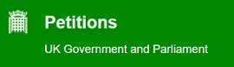
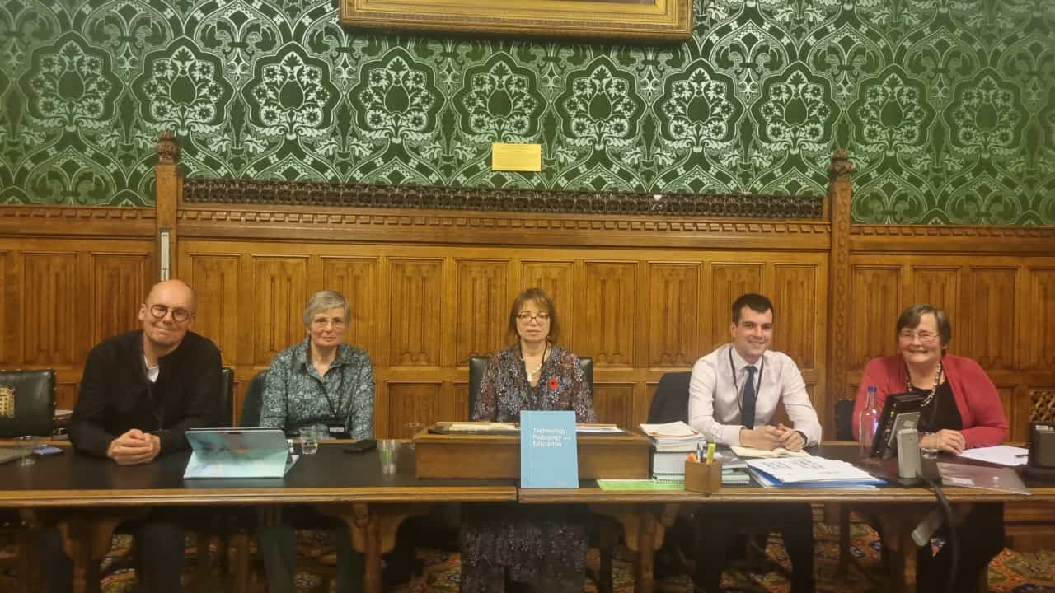
AI and Ed Tech Panel- Left to right-John Sibbald, Dr Mary Webb, Professor Sarah Younie( Chair) Simon Hay and Professor Marilyn Leask.

2. Dates for your diary

2024 - FEPG Dates

All Zoom meetings - Monday 7.00pm-9.00pm
All webinars/House of Commons (HoC) - Tuesday 6.00pm-8.00pm

Date | Location (HoC or Zoom) | Main focus
Monday 29th January | Zoom | HE/Gender Questioning
Monday 26th February | Zoom
Tuesday 19th March | Webinar | Low-cost options for Labour with CUREE
Monday 25th March | Zoom
Monday 29th April | Zoom
Tuesday 14th May | Webinar | The Open School webinar
Monday 20th May | Zoom
Monday 24th June | Zoom
July | No Meeting – committee rep/writing
August | No Meeting
Monday 23rd September | Zoom
Monday 28th October | Zoom
Tuesday 19th November | HoC face to face | Values and purposes of education with Mick Walters
Monday 25th November | Zoom
December | No meeting or social

Saturday, 20th January 2024:
Fabian Society New Year Conference (more details here:
FEPS-Fabian Society New Year Conference 2024: Plans for Power | Fabian Society.
Some of us will be in attendance on the day to promote the FEPG. Come and say hello if you’re going! If you know other Fabian Society members who aren’t signed up to the FEPG, why not suggest they pop along on the day to find out more about us?

Monday, 29th January 2023, 7pm:
Our first Zoom meeting focuses on two important issues:
- Higher Education funding, quality assurance and future
- Gender Questioning guidance.
It promises to be an excellent discussion and start to the year.

Monthly Zoom meetings- these will continue in 2023, usually on the last Monday of the month. The current dates for 2023 are as follows:
Jan 29th, Feb 26th, March 25th, April 29th, May 20th, June 24th, September 23rd, October 28th, November 25th.

3: House of Commons public meetings and Online Webinars:

Tuesday 19th March - Low-cost options for Labour with CUREE (Webinar)

Tuesday 14th May - The Open School (Webinar)

Tuesday 19th November - Values in Education (House of Commons)

4. Our new Cartoon series

One of our members has been producing cartoons that illustrate key issues that we want promoting in Education and more generally politically.

They are being released on Twitter/X from our Fabianeducation handle so when you see them please retweet if you can

We have posted cartoons that focus on:

- The National Moral Compass
- Covid Chaos cabinet – ‘who were you to decide’ and ‘politicians don’t understand the Science’ ( 2 Cartoons)
- Lords join Gove’s blob
- ‘Celebrating’ Conservative party education policies 2010-2024

Our last three recent cartoons have received a lot of traction and over 16K views so far.

We will also be posting them on our website and other social media in due course.

Here are three of our recent Cartoons. Many thanks to our colleague for the considerable work that has been put into creating these.

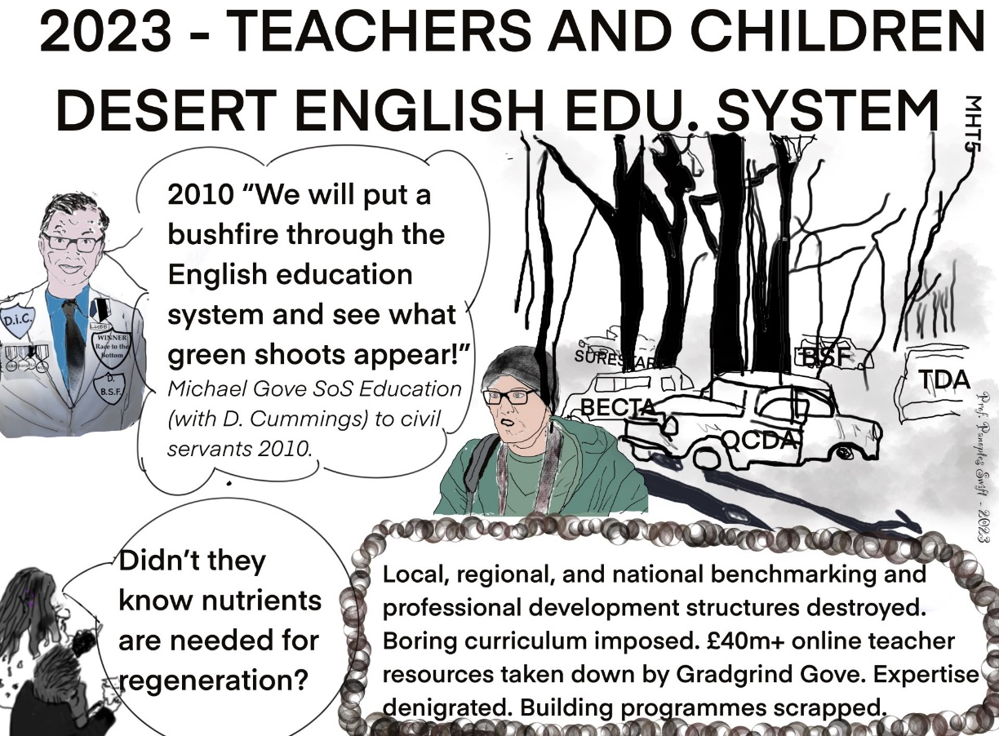

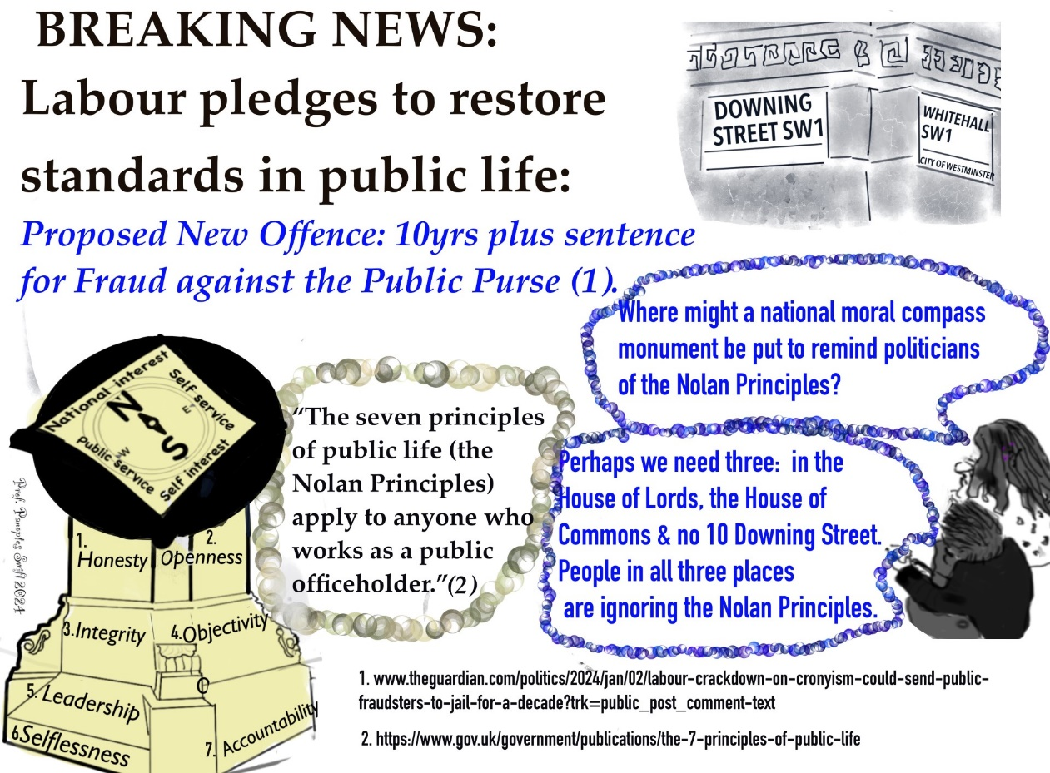

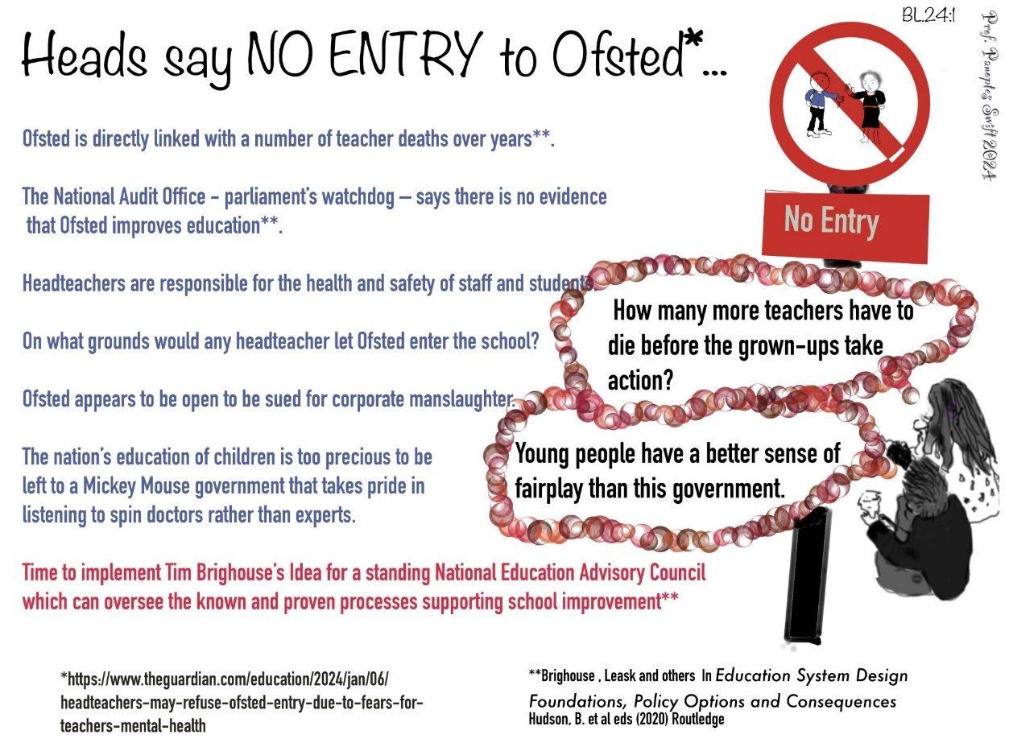

5. Further opportunities to write for us and share your ideas

Blogs
We are always on the lookout for new blogs from members. If there is an issue you would like to write about then please get in touch. Our blog pieces are usually under 1000 words. For inspiration take a look at our blog site here:
https://fabians4education.edublogs.org. There is an exciting development to our blogsite which we will discuss at our January 29th meeting.

Longer essays (aka the 'Journal')
If you would prefer to stretch out a little, we publish longer pieces (more than 1000 words) under the 'Journal' tab at our website. Take a look here: https://www.fabianeducation.com/journal
We haven't had any journal submissions for a while, so if you have some spare time over the Christmas and new year period and would like to get some ideas down, now is the time...

Six Searching Questions
If you have never written for us before, and would like to get started, we have a feature at our blog site called 'Six Searching Questions.' This is a short-form Q+A style blog, and it would be great to get lots of members contributing to this. Click on the link below and if you fancy tackling the questions get in touch.
We're not looking for lengthy essays or journals here- just short and concise answers to the questions, the kind of thing you can complete in ten or fifteen minutes:

https://fabians4education.edublogs.org/2022/01/23/a-new-series-of-posts-six-searching-questions-answered-by-professor-marilyn-leask/

6. What's new on our blog, social media pages and at the website

Blog: There’ve been some new pieces published at the blog since our last newsletter, the most recent being a piece on curriculum reform by our FEPG Curriculum Working Group. Take a look here: https://fabians4education.edublogs.org at two excellent recent pieces on the Children and Young People Mental Health Coalition, and Gender Questioning.

Twitter: Follow us @EduFabians. We're adding new followers all the time so please don't forget to retweet our posts to spread the word about us.

Our website www.fabianeducation.com remains the go-to source of information for all things relating to the FEPG. If you haven't already done so, please sign up for the 'Members' Area' of the site, where you will find documents like minutes of previous meetings.

All the best and see you soon!

The FEPG Organising Committee

Chair | Brian Matthews
Vice-Chair (Website and Blog) | Chris Harris
Communications | Marilyn Leask
Secretary | Norman Rimmell
Treasurer | Valerie Bossman-Quarshie
Journal and General responsibilities. | Sarah Younie, Alan Bainbridge, Deb Outhwaite. Rebecca Smith.
External liaison/ guest bookings | James Sheward
Twitter handle | @EduFabians
Blog address | http://fabians4education.edublogs.org/
Website address | www.fabianeducation.com
E-mail | FabiansEducation@gmail.com

